CMAA Georgia State University Student Chapter – Spring 2024

President – Tiffany Parker
Tiffany Parker, President of Georgia State University's CMAA Student Chapter. A senior majoring in Sport Administration with concentrations in Esports and Creative Media, Tiffany also minors in Hospitality Administration. Beyond her academic pursuits, Tiffany enjoys exploring local coffee shops and engaging in curated shopping experiences. Her dedication to professional growth is evident as she eagerly anticipates collaborating with and learning from the talented individuals within the chapter. Tiffany's role as President underscores a commitment to steering the chapter towards continued success, demonstrating a dynamic and dedicated approach to its objectives.
Event Chair – De’Andrier Coakley
A Master of Global Hospitality Management student with a fervent passion for the private club industry, she currently holds the position of Events Chair within the Student Chapter. Recently honored with the CMAA GA Chapter Student Scholarship, her dedication to excellence in the field is commendable. Post-graduation, she aspires to embark on the journey toward obtaining her Certified Club Manager (CCM) designation, solidifying her commitment to continuous professional growth and leadership within the dynamic realm of hospitality.
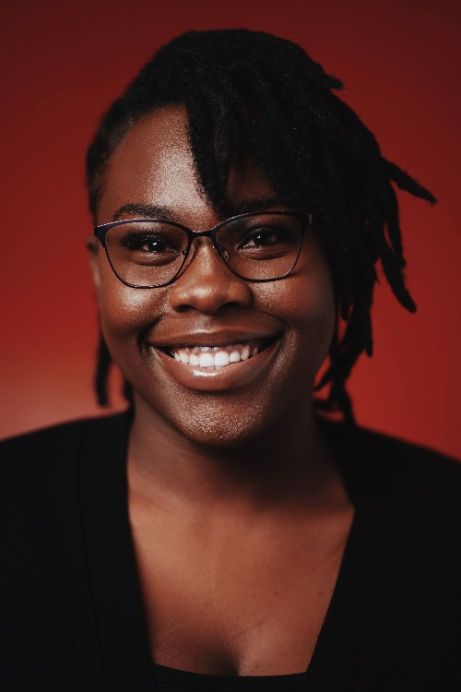
Communication Chair – Bradon Ly
Currently a senior at Georgia State University, he is diligently pursuing a major in Management with a focused concentration in Supply Chain Management. Alongside his academic pursuits, he enjoys engaging in pickleball as a recreational activity. In the capacity of Communication Chair, he plays a pivotal role in managing public relations efforts and ensuring seamless communication within the club management organization.
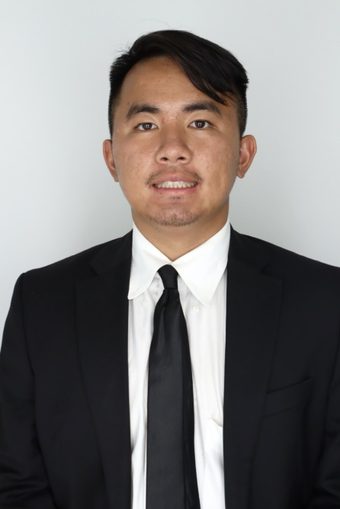
Ambassador – Najah Brown
In her third year as a Hospitality Administration major, Najah Brown, originally from Charlotte, North Carolina, holds a passionate dedication to advancing her career within the hospitality industry. With a particular interest in event operations, whether in hotels or conferences, Najah currently applies her knowledge and skills at Capital City Club. This valuable real-world experience, combined with her academic pursuits, positions Najah as a promising professional who seamlessly integrates theoretical knowledge with practical insights in the dynamic field of Hospitality.
