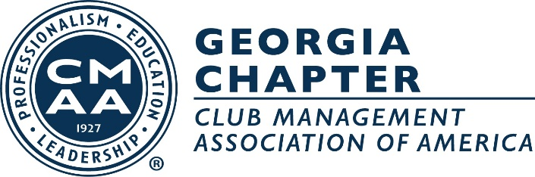
MEAD GRADY/JOHN JORDAN AWARD
FOR RECOGNIZING ACHIEVEMENT IN CLUB MANAGEMENT
GEORGIA CHAPTER NOMINATION FORM
(General Managers, Club Managers and Assistant Managers are eligible)

In order for the Nominating Committee to effectively select potential candidates, this form must be completed in detail no later than October 1, 2023 and sent to: Allegra Johnson at Gamanagingdirector@gmail.com. Please follow the outline described in Section II. Handwritten or typed is acceptable, however, Section II should be attached as a separate document.

SECTION I. PERSONAL DATA (of individual being nominated):

LAST NAME: ____________________________________FIRST NAME: _____________________MI:_____

CLUB NAME:______________________________________________PHONE #:______________________

CLUB ADDRESS:__________________________________________________________________________

JOB TITLE:_______________________________________________________________________________

SECTION II: PROFILE OUTLINE

Please attach specific written summaries on each of the categories below:

- CLUB WORK HISTORY
- SPECIAL ACTIVITY/ACTIVITIES THAT MAKE THIS MANAGER NOTABLE
- OTHER HONORS, ACHIEVEMENTS OR CONTRIBUTIONS

SECTION III. PERSON SUBMITTING RECOMMENDATION

NOMINATED BY:__________________________________________NOMINATION DATE:____________

CLUB:___________________________________________________CLUB PHONE #___________________

SECONDED BY:_______________________________________ SECONDED DATE:__________________

CLUB:__________________________________________________CLUB PHONE #:___________________

